Rounding Issues in Plane separation
August 14, 2023
14:54

Symptom: 3D Volume is not auto generated on import.
Root Cause: Rounding Error in Eclipse causes it to believe that the image spacing is not correct.
Solution: Manually Generate 3D image in Selection workspace
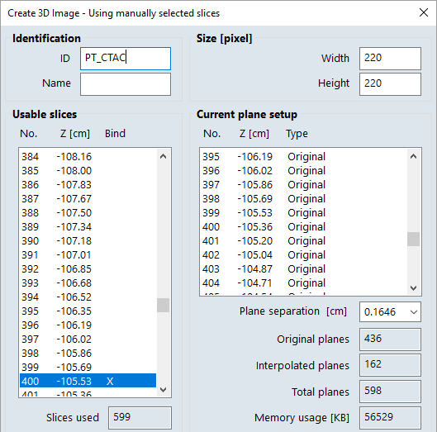
When doing so, Image overlap warnings may appear:
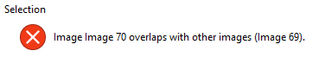
These messages can be safely acknowledged and ignored.

Alternatively, it may be possible to tweak the plane separation setting to prevent the warnings (Not yet tried). This will result in interpolated images in the 3D image volume.
